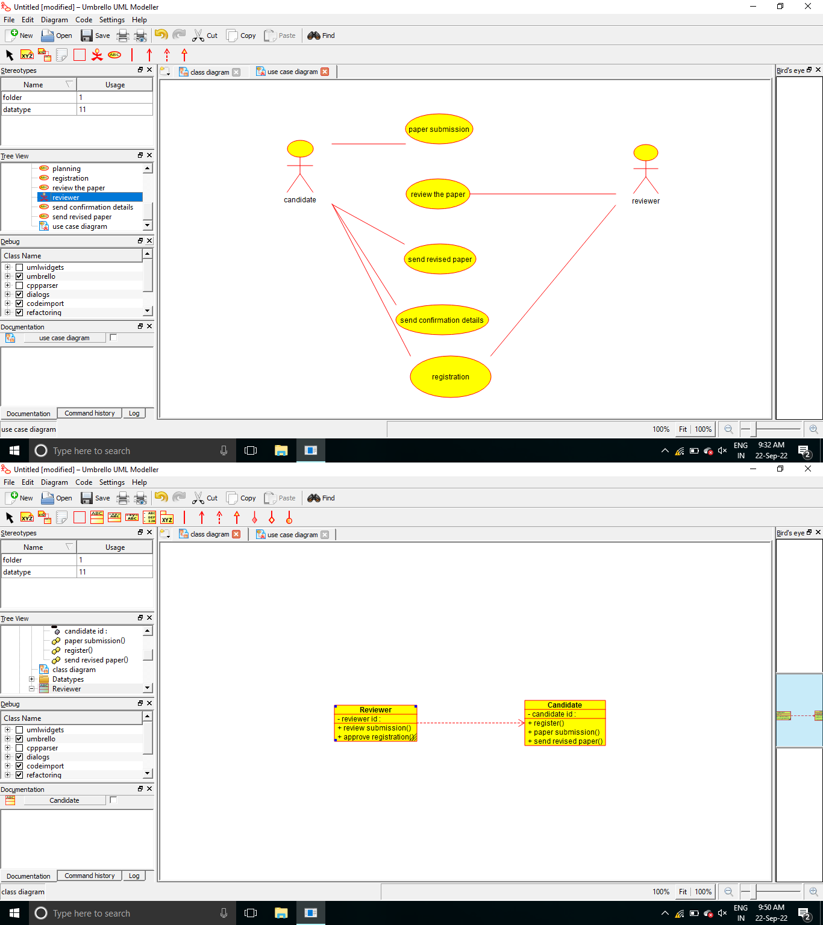

/**

* Class reviewer

*/

public class reviewer {

//

// Fields

//

private void reviewer_id;

//

// Constructors

//

public reviewer () { };

//

// Methods

//

//

// Accessor methods

//

/**

* Set the value of reviewer_id
* @param newVar the new value of reviewer_id

*/

private void setReviewer_id (void newVar) { reviewer_id = newVar;

}

/**

* Get the value of reviewer_id
* @return the value of reviewer_id

*/

private void getReviewer_id () { return reviewer_id;

}

//

// Other methods

//

/**

*/

public void review_the_paper()

{

}

/**

*/

public void approve_regn()

{

}

}

/**

* Class candidate

*/

public class candidate {

//

// Fields

//

private void id; private void name;

//

// Constructors

//

public candidate () { };

//

// Methods

//

//

// Accessor methods

//

/**

* Set the value of id
* @param newVar the new value of id

*/

private void setId (void newVar) { id = newVar;

}

/**

* Get the value of id
* @return the value of id

*/

private void getId () { return id;

}

/**

* Set the value of name
* @param newVar the new value of name

*/

private void setName (void newVar) { name = newVar;

}

/**

* Get the value of name
* @return the value of name

*/

private void getName () { return name;

}

//

// Other methods

//

/**

*/

public void paper_submission()

{

}

/**

*/

public void register()

{

}

/**

*/

public void send_the_revised_psper()

{

}